1. **Bit rate :**

Bit rate is the number of binary bits (1s or 0s) transmitted per second.

Bit rate = number of bits transmitted/ total time (in seconds)

The bit rate can also be defined in terms of baud rate:

Bit rate = Baud rate x bits per signal or symbol

1. **Data rate** is the rate at which data is transferred through some telecommunications or computing medium. It represents the number of binary digits (bits) that can be transferred or processed per unit of time. The basic unit is the number of**bits per second**. The correct abbreviation is bit/s although it is often seens as b/s or bps.

Bit rate of a video signal is the no of bits per frame per second. Also, data rate is the no of bits per second.

1. **Baud rate :**  
   Baud rate is the rate at which the number of signal elements or changes to the signal occurs per second when it passes through a transmission medium. The higher a baud rate is the faster the data is sent/received.

Baud rate = number of signal elements/total time (in seconds)

* 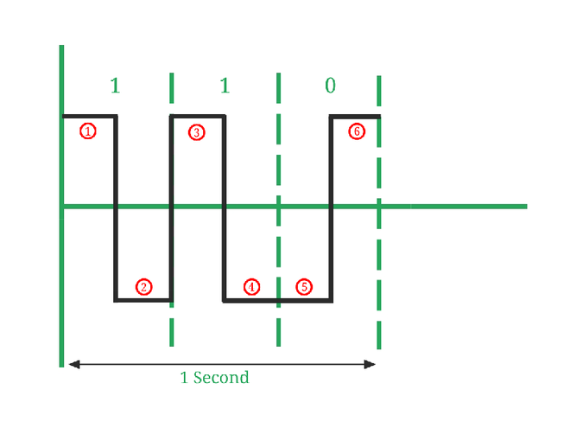
* In *Image 2*, Number of signal elements (marked in red color) = 6, Number of bits transmitted (1, 1, 0) = 3. So, Here Bit rate = 3/1 = 3 bits per second. and, Baud rate = 6/1 = 6 baud per second.

Baud rate is important because:

* Baud rate can determine the bandwidth requirements for transmission of the signal.
* Baud rate is also used for the calculation of the Bit rate of a communication channel.
* It is a tuning parameter (i.e., it adjusts the Network congestion in data networking) for the transmission of a signal.
* It specifies how fast data can be sent over a serial line or serial interface (it’s an interface that sends data as a series of bits over a single wire.).

| S.NO | Bit Rate | Baud Rate |
| --- | --- | --- |
| 1. | Bit rate is defined as the transmission of a number of bits per second. | Baud rate is defined as the number of signal units per second. |
| 3. | Bit rate emphasized computer efficiency. | While the baud rate emphasized data transmission. |
| 4. | The formula of Bit Rate is:  = number of bits transmitted/ total time (in seconds)  =baud rate x the number of bit per baud | The formula of Baud Rate is:  = number of signal elements/ total time (in seconds)  = bit rate / the number of bit per baud |
| 5. | Bit rate is not used to decide the requirement of bandwidth for transmission of the signal. | While baud rate is used to decide the requirement of bandwidth for transmission of the signal. |
| 6. | Bit Rate cannot determine the bandwidth. | Baud rate can determine the amount of bandwidth necessary to send the signal. |
| 7. | It counts the number of bits travelled per second such as Kbps, Mbps, Gbps, etc | It counts how many times the state of a signal is changing. |

